Overview of Spokespeople
Please visit the Media Centre located on the Ground Level, in room E2, or contact Michèle Rogerson, micheler@skillscanada.com or 613-266-4771, to arrange for an interview with any of the following people or a tour of the venue.

Select spokespeople are also available to take part in French interviews.

Skills/Compétences Canada Spokespeople and Special Guests

John Oates
President of Skills/Compétences Canada
John Oates, the President of Skills/Compétences Canada, has had a long history with the Skills Movement in Canada. He has been the President of Skills Canada – Newfoundland and Labrador since 2004, the same year he joined the national Board of Directors. During his time on the Board of Directors of Skills/Compétences Canada, he has served in the positions of Director, Secretary, and Vice-President.
John has long been a strong proponent of promoting careers in the skilled trades and technologies. He recently retired from College of the North Atlantic, where for almost 40 years he was a very vocal advocate for increasing trade and technology training opportunities in his home province, as well as across the country. In addition to his work with Skills/Compétences Canada, John has extensive experience with Board governance and strategic planning. He currently sits on the Boards of Directors of the Public Service Credit Union, League Data, Together By Design and the Anna Templeton Centre for Craft, Art and Design.
John has been in the role of President on the Board of Directors of Skills/Compétences Canada since 2014, leading this organization into the future. He has dedicated the next year to continuing his advocacy role in highlighting the important roles played by skilled tradespersons and technologists in making Canada a truly great country.


Shaun Thorson
CEO, Skills/Compétences Canada
Shaun Thorson, Chief Executive Officer of Skills/Compétences Canada is a tireless champion of skilled trades and technology careers for Canadian youth. CEO since 2006, Shaun has held various positions within the Skills/Compétences Canada organization at the provincial and national levels for the past 20 years.
Shaun recognizes the vital role of a strong and vibrant skilled trades & technology workforce in maintaining Canada’s global economic leadership and fosters engagement with thought-leaders to ensure best practices and positioning. Known for the annual Skills Canada National Competition, Skills Canada is also member of WorldSkills. Within this international body Shaun has chaired the Sustainability Initiatives, Quality Assurance Management Council, the WorldSkills Americas Technical Committee and was Canada's WorldSkills Technical Delegate from 2006-2013 and in 2017.
Shaun is also currently the Board Chair of the Canadian Welding Bureau Foundation (CWBF) and Chairs the WorldSkills, CEO-National Skills Organization Council.


Sherry Holmes
Contractor, Part-time Designer, & weekend DIYer!
Sherry Holmes grew up watching, working and playing with her dad, Celebrity TV Host & Contractor, Mike Holmes. As early as 16-years-old she began working behind-the-scenes of Mike’s breakout series, Holmes on Homes®. In 2008, after a Crew member fell ill, Sherry decided to strap on her own tool belt and travelled to New Orleans to help build a hurricane- and flood-resistant home for a victim of Hurricane Katrina, in Holmes in New Orleans.
Since then she has been a permanent member of Mike’s Crew, first on Holmes Inspection and then on Holmes Makes It Right, and more recently Holmes: Next Generation, airing on DIY & HGTV in 2018, where she teams up with her brother, Mike Jr. (and learning a few tricks from her famous father) where they recue homeowners from dysfunctional homes, shady contractors and do-it-yourself projects gone wrong.
As a big supporter for youth who want to get into the trades, Sherry continues the family support to Skills Canada and World Skills. She also mentors young women through Conestoga College’s Jill of All Trades, and acts as an Ambassador for Habitat for Humanity’s Annual Women Build Event, a program that calls on women to help build stronger, safer communities.
On and off the jobsite, Sherry continues to change the face of Canada’s skilled trades workforce, demonstrating that women can bring an entirely new dimension to the construction industry that makes it fundamentally stronger from the ground up. Like her proud father, everything she teaches and believes in is based on quality, integrity and trust.
TWITTER: @SHERRYL_HOLMES FACEBOOK: @SHERRYHOLMES
INSTAGRAM: @HOLMESSHERRY



Paul Lafrance
The "Deck Guru"

Paul Lafrance, most commonly known as the “Deck Guru” both in the Reality TV macrocosm as well as in the average North American home, is also a musician and lead singer/songwriter in the band, Found in the Fury, the owner and founder of the international design company, Paul Lafrance Design, and has nearly completed his training as a Jedi Master.

Paul is the host of HGTV’s Decked Out, Disaster Decks, Custom Built, and Deck Wars as well as one of the judges on Canada’s Handyman Challenge, and co-designer on the HGTV hit show, Home to Win. He is currently working on a digital series called Backyard Revolution. He moonlights as the head designer at PLD. Since 1997, he’s been designing and installing everything from custom built homes, basement transformations, corporate facades and common areas, to cutting-edge backyard retreats.

Paul and his wife Janna live with their four daughters just outside of Toronto, Ontario. As a father of four girls, Paul is a strong advocate for women in the skilled trades in Canada.

Quote:

“I’m passionate about helping people find a way to design places of rest on their own property, mainly because I think the world around us has gone a little bid mad. We all need a place we can easily retreat to, to reconnect with our families, our friends, and even ourselves.”

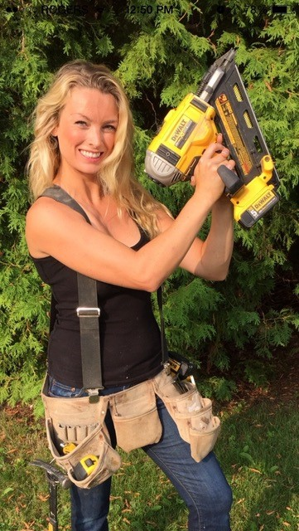

Kate Campbell
HGTV Star Founder of KateBuilds Inc.
Kate Campbell entered into the skilled trades in 2005. After graduating high school and realizing that the university path just wasn’t for her, Kate applied to a "Women In Skilled Trades" (WIST) course based out of Burlington, Ontario. After being accepted to the course and picking up a power tool for the first time, Kate realized she had found her passion. During the three month program, she was introduced to carpentry, electrical, plumbing, finish carpentry and several other trades. Kate had always known that she wanted a career where she could stay active, be creative and constantly be challenged. Well... she found one!
Kate has been working in the television and renovation industry for over twelve years and has been taught by some of the Canada's top renovators. She can be seen as part of the crew for HGTV’s "Holmes On Homes", "Holmes in New Orleans", "Holmes Inspection" and assisting the final contestants as a part of "Handyman Superstar Challenge".
While working with these shows she was faced with many challenges and was also exposed to every aspect of home renovation and building. Kate was personally involved in building two homes and helped out with countless renovations. She’s worked with the best designers, best builders and the most cutting-edge building materials out there.
Kate Campbell has also been featured as one of the crew in HGTV’s hit shows "Decked Out" and “Disaster Decks” where she helps build some of the most interesting and unique decks out there.
To top it all off, most recently Kate was asked to participate in HGTV Canada’s hit show “Home to Win” as one of the hosts and celebrity contractors.
When she’s not working with the show, Kate also runs her own renovation company with her husband - KateBuilds Inc. They recently finished renovating and restoring a 150-year-old farmhouse together.
Kate is extremely passionate about speaking to young women who are considering entering the trades. Kate is focused on “changing the face” of the skilled trades and ESPECIALLY passionate about being an advocate for women and supporting causes that are important to her.

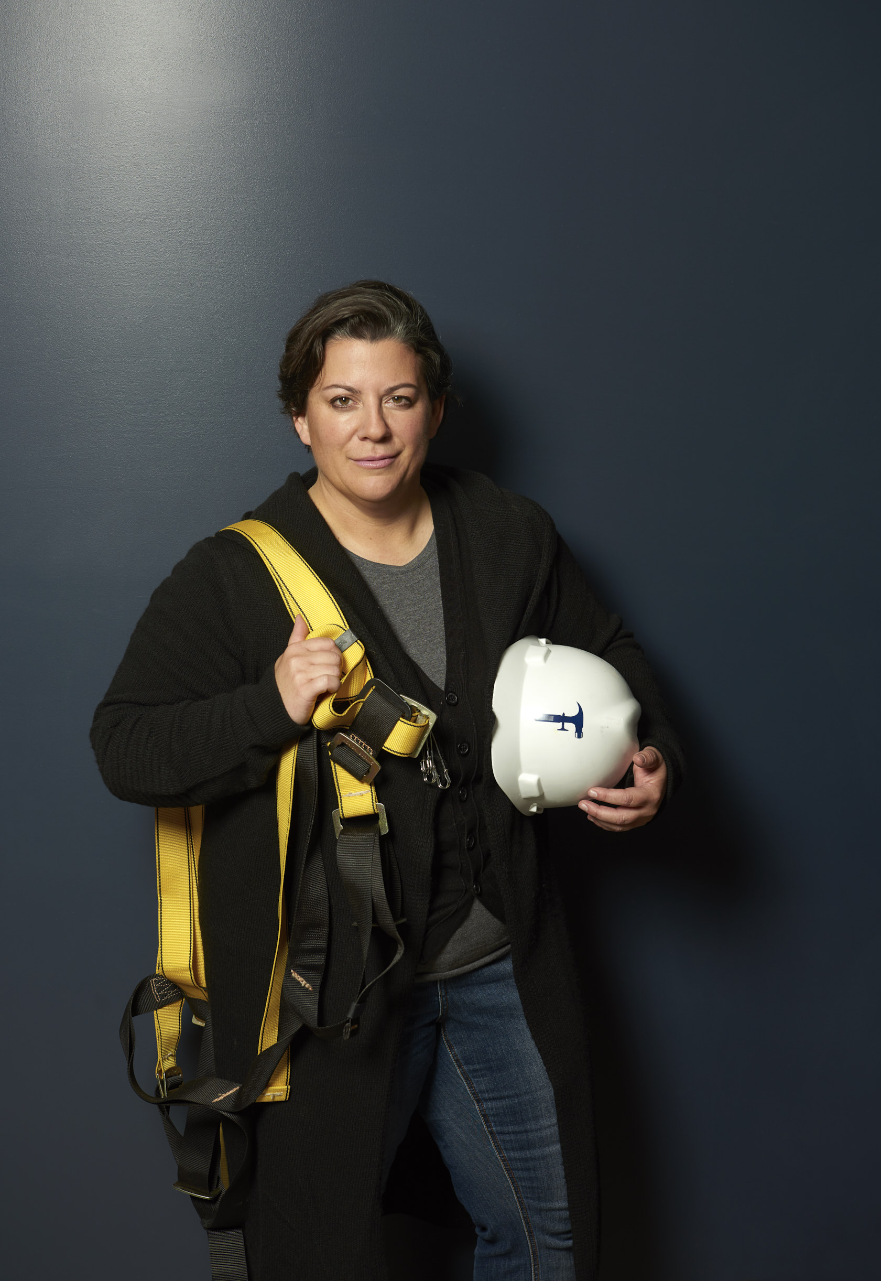

Mandy Rennehan

Blue Collar CEO™ & Founder of Freshco.ca
Sought-after speaker, multiple award-winning entrepreneur, and trade industry ambassador, Mandy Rennehan is redefining the collar, blue™, and inspiring youth to join the dynamic skilled trades industry. Mandy is the Blue Collar CEO™ & Founder of Freshco.ca (not the grocery store!), Canada's #1 retail reconstruction and maintenance provider, operating across Canada and the eastern United States serving clients like Anthropologie, Apple, Banana Republic, Home Depot, Lululemon, Nike, Restoration Hardware, Sephora, The Gap, Tiffany & Co., plus many more. She is also the co-founder of RennDuPrat, a master design and custom fabrication company.
Mandy is humbled by the many awards she’s received including, the RBC Canadian Women Entrepreneur Momentum Award, WXN’s Top 100 Most Powerful Women, the LGBT Business of the Year Award, Profit Magazine’s W100, and Atlantic Business Magazine’s Top 50 CEOs. As one of Canada’s top entrepreneurs, she’s also been featured in the Canada 150 Women book , The Globe and Mail, Financial Post, Chatelaine, CTV, BNN and many more.
Her uncensored honesty is matched by her quick wit, East Coast humour, and big heart. It’s impossible to remain unchanged after coming into contact with this authentic, self-made powerhouse.
Twitter: @MandyRennehan Instagram: @Freshco_Inc www.Freshco.ca

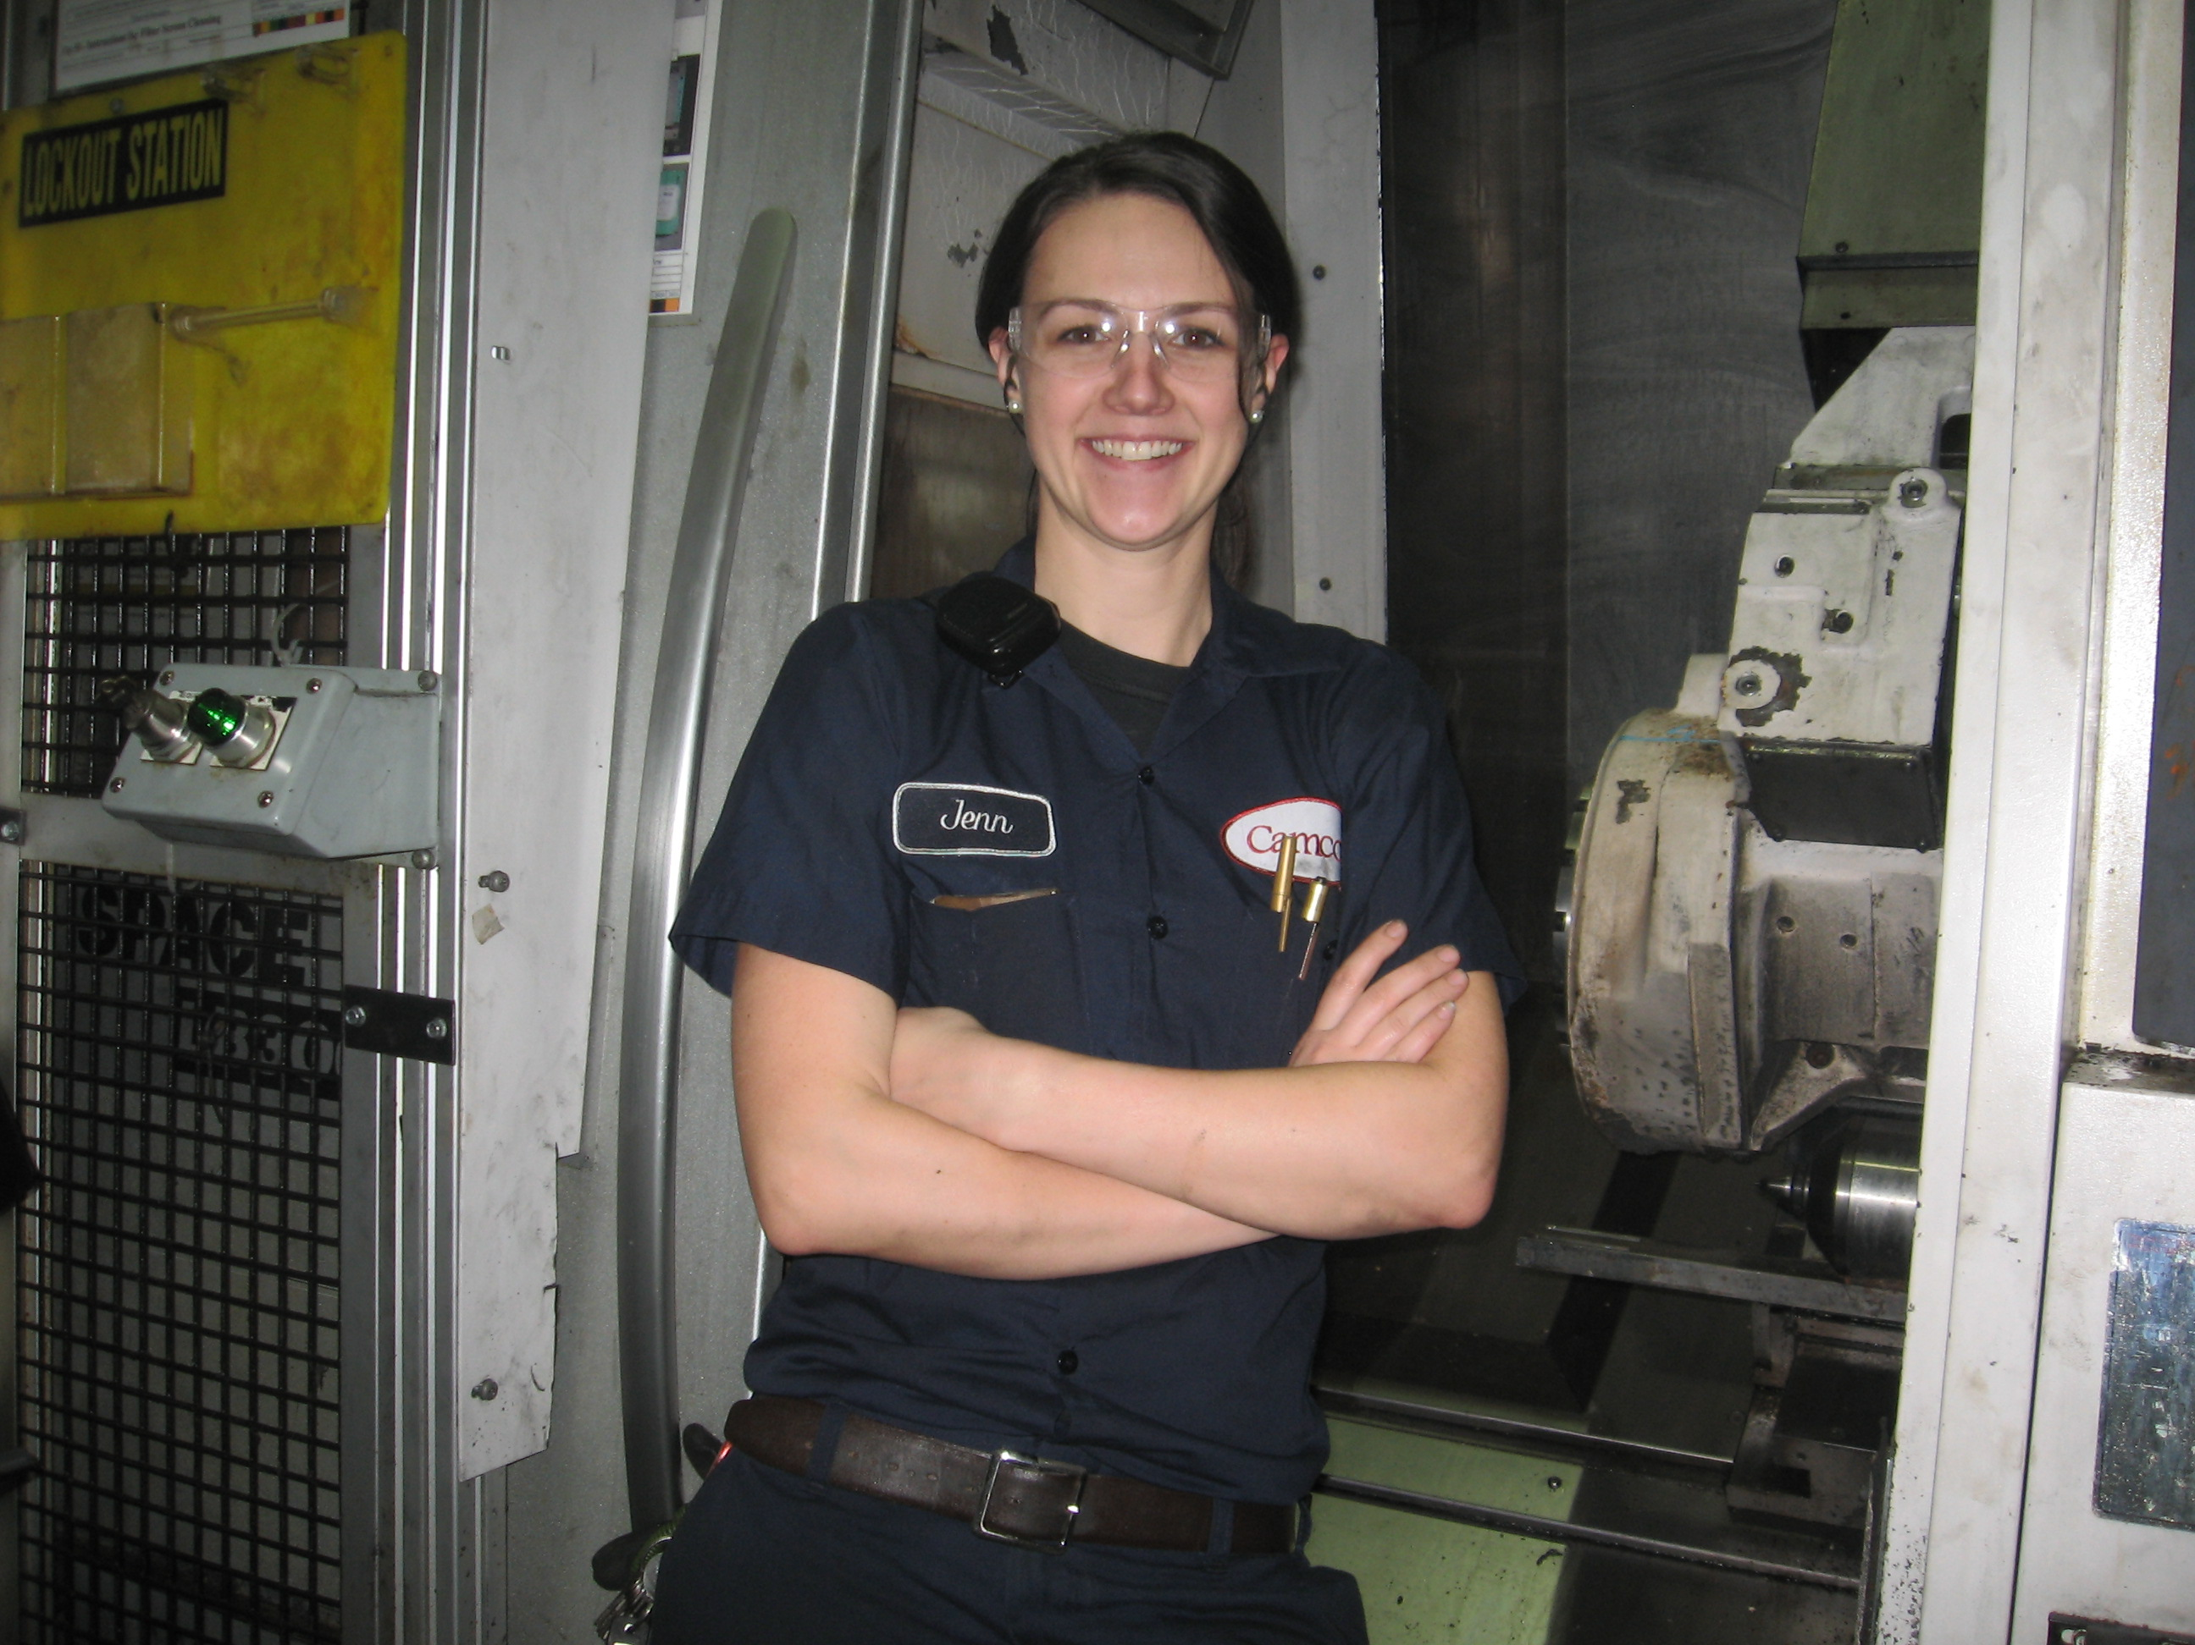

Jennifer Green
National Lead, Skills Canada National Alumni Committee and President, Skills Ontario Alumni Association
Skilled tradesperson, Jennifer Green has made remarkable contributions as an advocate for the advancement of trades and women in trades and technologies, through her leadership, individual achievements and various presentations and speaking engagements. She graduated from Conestoga College in 2008 as a licensed Industrial Maintenance Mechanic Millwright with a Certificate of Apprenticeship and Certificate of Qualification through the Ministry of Training Colleges and Universities, where she was employed at Linamar. She is now a Maintenance Planner/ Scheduler, at the Upper Grand District School Board.
Jennifer is a sought-after speaker, and works actively with Conestoga, educational partners, Skills Ontario, Skills Canada, community, companies and organizations; for the advancement of trades, gender and age gap. She is a tireless advocate for the promotion of women in non-traditional careers, is a mentor for trades and apprenticeships, and is a trail blazer and a role model for women in the skilled trades.
This has led her to various honours and awards, including the YM-YWCA Women of Distinction Award; Trades in 2013, and the Conestoga College Alumni of Distinction Award in the same year. She also competed in the Industrial Mechanic Millwright competition at Skills Ontario in 2008, earning Gold. Moving on to compete that same year at the national level at Skills Canada, earning Silver.
Green has been involved with Skills Ontario since 2005, through numerous volunteer events, mentoring and speaking engagements. She also aided in the creation of the Skills Ontario Alumni Association in 2016, and became the inaugural president; where she continues to evolve the association, and others as the National and Ontario Lead on the Skills Canada National Alumni Committee.

Skills Canada: National and International Competition Alumni
Many former SCNC and WorldSkills alumni volunteers will be in attendance to make the 2018 Skills Canada National Competition a winning success. As well as being on site, they are also on hand to speak about their competition experience and how it has helped them in their careers.

National Technical Committee Members (Competition Experts)
Each of the 44 competition projects is designed and judged by a National Technical Committee (NTC) made up of industry experts from across the country. These experts are on hand to discuss specifics about contest areas.

Industry Partners, Sponsors and Suppliers
Industry representatives working with Skills/ Compétences Canada to make the SCNC possible are on hand to discuss skilled trades opportunities, needs and issues related to their sectors.

